3.2 The Derivative as a Function Worksheet

- Find the derivative of the function using the definition of the derivative. State the domain of the function and the domain of its derivative.

- The graph of the function is shown below.
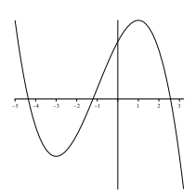

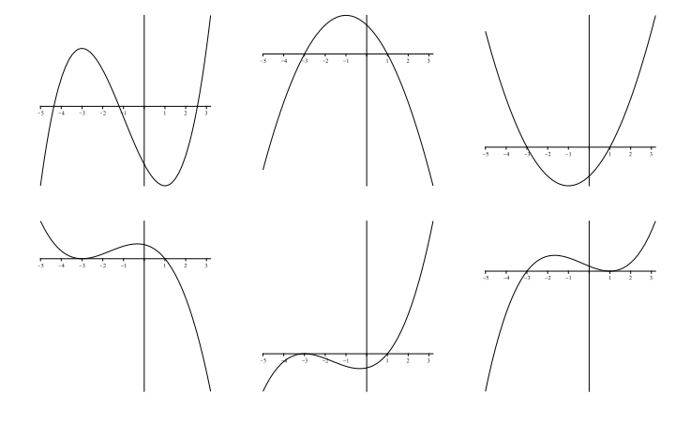
One of the six graphs below is the graph of . Circle the graph of .

- Match the graph of each function in (a) – (d) with the graph of its derivative in I-IV.
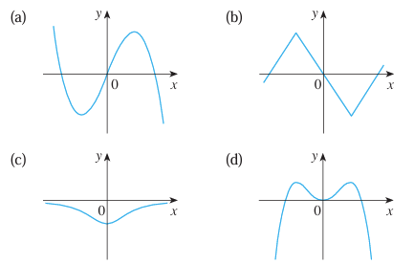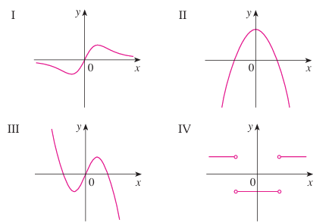

- The graph of f is given. State, with reasons, the numbers at which f is not differentiable.
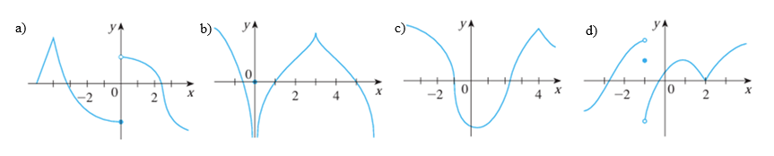

- Suppose that we know that is an even function that is differentiable at . we know that has the following values:
Find .

- TRUE or FALSE: If a function is continuous at , then must exist.

